Hutton Rudby

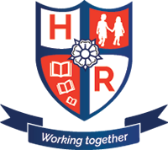
Curriculum News

Year 5 – Spring Term 2 2018
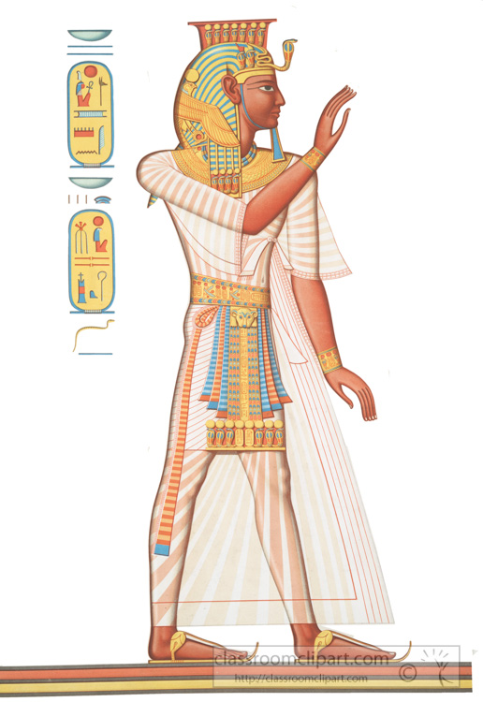
Our topic:
Pharaohs
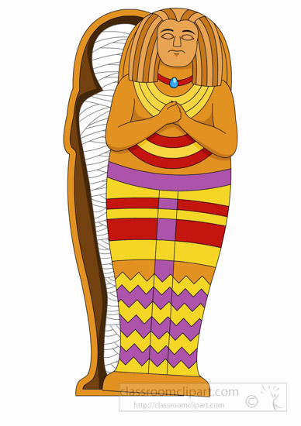

We will be: Travelling back 5000 years to the dusty realms o of Ancient Egypt.
Maths
Multiplication & Division
Geometry
Fractions
Measures
Statistics

PE takes place on Tuesday and Wednesday afternoons. Don’t forget to send in their PE kits!

Reminders
English
Chronological Reports
Fact Files
Mystery Stories
Play Scripts
@HuttonRudbyPri
www.huttonrudbyprimary.co.uk

Science
Living Things / Habitats
Computing
Coding
Geography
Human & Physical features. Tourism.
History
Ancient Egypt
Art & Design Technology
Drawing, creating.
PE
Football
RE & PSHCE
Easter

