Hutton Rudby

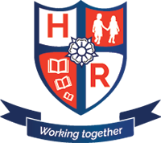
Curriculum News

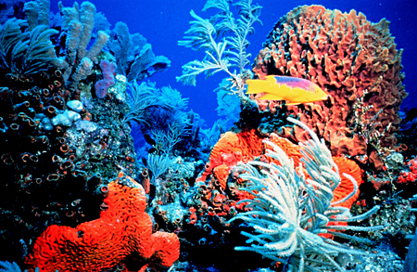Year 4 – Spring Term 2 2018
Our topic:
The Blue Abyss

We will be:
Making a deep-sea voyage of discovery.
Please make sure all homework books are handed in on a Thursday.
@HuttonRudbyPri
www.huttonrudbyprimary.co.uk
P.E
Please ensure that full outdoor and indoor PE kits are in school at all times.

Maths
Place Value
Four rules of Number
Arithmetic
Reasoning
Science
Living things and habitats
Computing
Programming
Geography
Seas and oceans of the world
History
19th Century exploration
Art & Design Technology
3-D models
PE
Dance
RE & PSHCE
Easter
English
Poetry
Dilemma stories
Persuasive letters

