**Hutton Rudby**



**Curriculum News**

**Year 5 - Autumn Term 2 2017**

**Our topic:**

Time Traveller

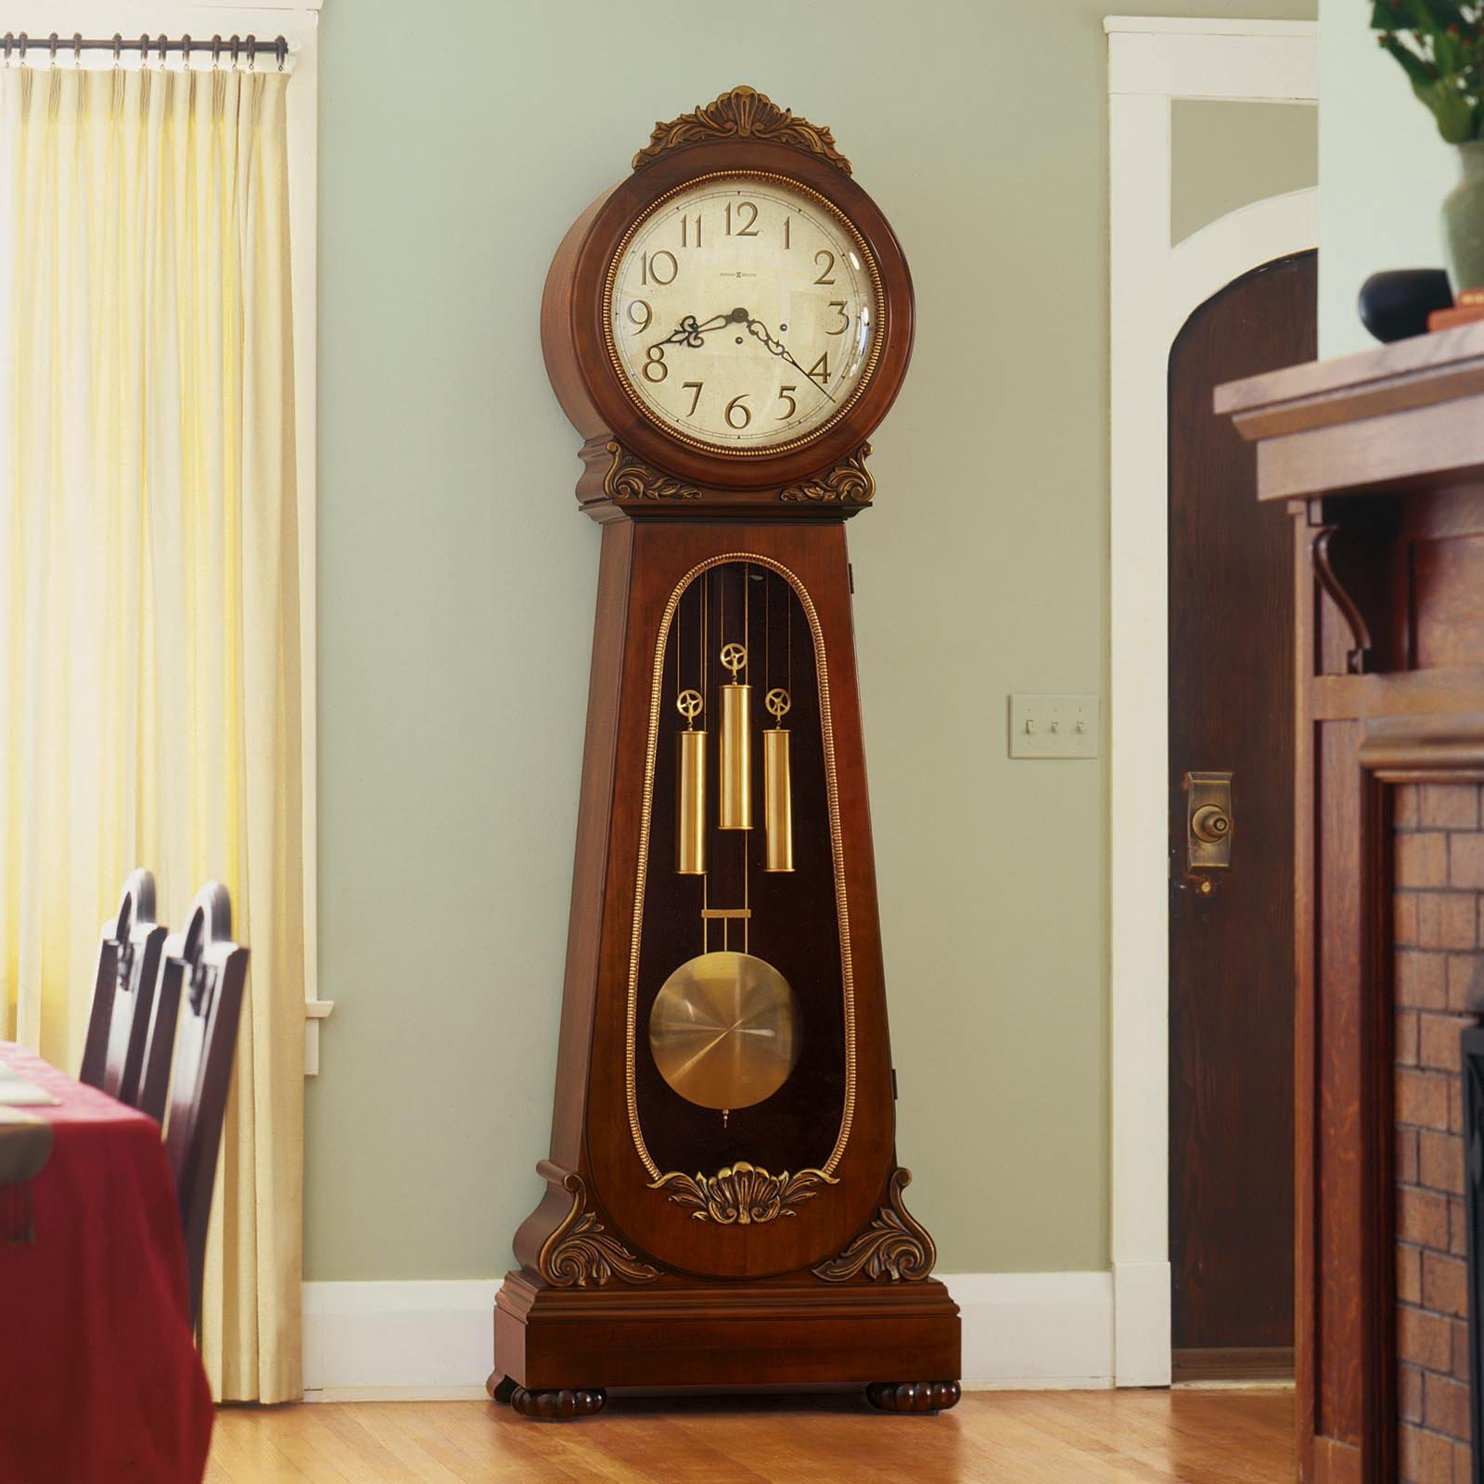

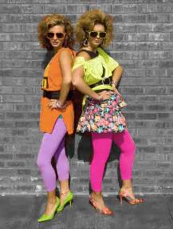

**We will be: Looking at journeys through time.**

**Maths**

Mental methods

Fractions

Multiplication & Division

Statistics

**English**

Adventure Narrative

Free verse poetry

Leaflets

Persuasive Letters

PE takes place on Tuesday and Wednesday afternoons. Don’t forget to send in their PE kits!

Reminders

@HuttonRudbyPri

www.huttonrudbyprimary.co.uk

**Science**

Animals (inc. humans)

**Computing**

Digital portraits; data logging.

**Geography**

Local changes

**History**

Changes over last century.

**Art & Design Technology**

Great artists.

**PE**

Football

**RE & PSHCE**

Christmas