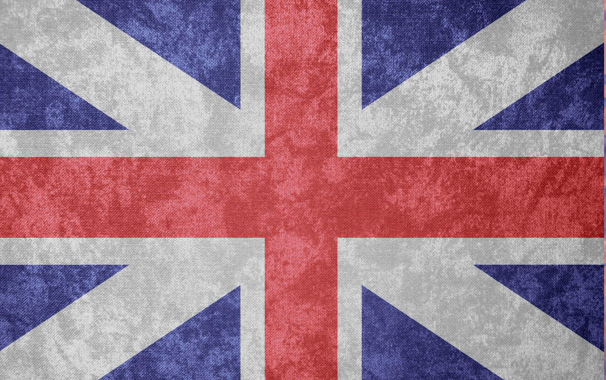
British Values
Picture News 8th-14th March
Individual Liberty
We will use our heads and our senses and listen to adults to decide whether the food we eat is safe. We will try our hardest to not waste the food we have.

