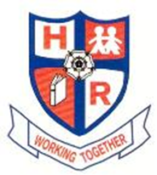

**HUTTON RUDBY PRIMARY SCHOOL**

**Curriculum Letter - Year 3 - Mr Simpson January 2017**

**English** Children this term will cover a wide variety of different genres. We begin the term looking at narratives and informal diary entries before moving on to non-chronological reports. We plan to use our knowledge and engagement of Ancient Egypt to help aid and stimulate our writing throughout this term. The children will have the opportunity to express feelings, imaginative thoughts and emotions through a variety of different activities this term as we look to deepen our understanding of grammar and punctuation.



**Maths** This term in Maths the children will be building on their basic knowledge of the four operations and applying it to different strands of the mathematic curriculum. Statistics, shape, measurement and Roman numerals are all going to be covered along with reinforcing the understanding of number and place value. We will also look to incorporate the reading of numbers and writing them as words through our Ancient Egypt topic in History.

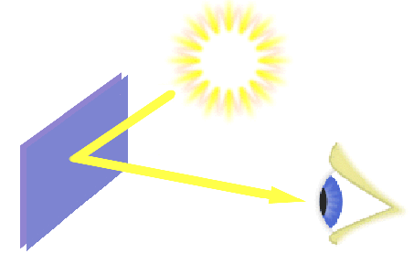

## Science This term the children will finish off our topic of ‘Light and Reflection’ by creating periscopes, changing the direction the light is travelling and creating shadows using different objects. Moving on from this children will then begin investigating and exploring the Science around magnets and forces. We will look to identify which materials are magnetic and how the different forces vary.

**Computing** This term we continue to build on working on our key computer skills. Children will get the chance to freely write stories, research different ideas and build PowerPoints for demonstrations this term which are all vital life skills. We will also look at some coding and look to create a game that another member of our class can play.

## Design Technology The children will be given the chance to create some Egyptian Death Masks that again tie into our Ancient Egypt topic. We will look to build these masks from scratch like the true Ancient Egyptians.

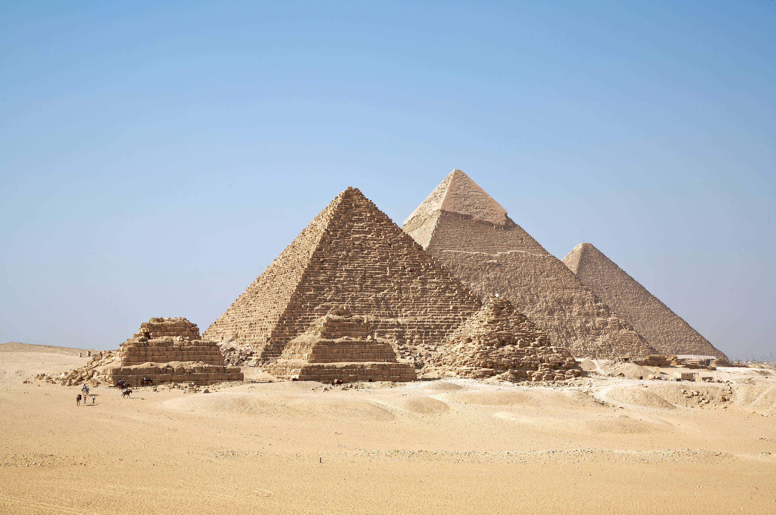

**History** The children will be learning all about Ancient Egypt this term. We will investigate what it was like growing up in Ancient Egypt along with giving the children an opportunity to find answers to questions they independently want to investigate. The children will be travelling back in time as we play games that the Ancient Egyptians played during their time and also recreating a traditional mummification (minus the gory parts!)

**Geography** During this term the children will be working on the topic ‘Living in the freezer’ we will explore the natural environment of some of the coldest places on earth along with identifying their geographical location. Children will be given the chance to research animals and habitats in these extreme conditions focusing on how animals have adapted to life in the conditions.



**Art** The children will be given the chance to use a variety of different tools to enhance their learning in Art. This term we plan on creating Hieroglyphics and creating a detailed sketch of the Egyptian pyramids.

**Music** The children will continue to learn a repertoire of songs which will be used to develop their understanding of different levels of pitch, steady beat, rhythm and the one beat rest. They will complete an in depth study based on the unit of work Play it again.

## PE Our PE sessions will continue to be on Tuesday and Friday. In PE this half term we will be learning the how to play Quicksticks in anticipation for an up and coming tournament later in the term. We will learn all about how to play and the techniques needed to succeed as a hockey player. In tandem with this the children will be going swimming every week until the February half term and will grow, build upon or master their swimming ability.

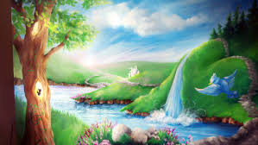

**RE** This half term the children will be enhancing their knowledge and understanding of Creation Stories in the Jewish, Christian and Hindu faiths**.**

**PSHEe** Our citizenship programme will focus upon Going for Goals. The children will have the opportunity to set their own goals and develop feelings of self-worth.

**French** In French we will be learning about La Jungle through a mixture of: repetition, speaking and listening, songs and games.