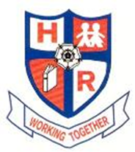
HUTTON RUDBY PRIMARY SCHOOL
Curriculum Letter Year 1 January 2017

Welcome to Spring Term 2017 in Year 1
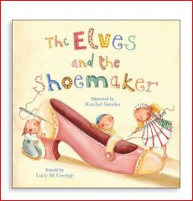
English This half term, the children will be exploring traditional tales as the basis for our own writing. We will be learning about characters, events and themes in traditional tales and use this to explore different text genres including newspapers, descriptive and imaginative writing, play-scripts and poetry. Our non- fiction text types will be Explanation Texts and Information texts based on our Topic work Up, Up and Away!
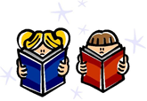
This term we will be aiming for all the children to be joining their letters in our handwriting lessons. We will continue with phonic and spelling lessons. Our spellings this half term will be drawn from Phase 5 Letters and Sounds (see http://www.letters-and-sounds.com/). We are learning about ‘alternative graphemes’ (different ways of spelling the same sound) and spelling patterns.
We will be concentrating on comprehension in reading. In Group Reading sessions we will be building our deduction and inference skills. Thank you for your continued support with reading at home! Reading books from school will continue to be changed on Mondays, Wednesdays and Fridays.

Maths This half term in Maths we are focussing on:

• Solve problems with addition and subtraction

• Use place value and number facts to solve problems

• Apply knowledge of mental and written methods

• Recall and use multiplication and division for the 2x, 5x, 10x tables

• Solve simple problems involving addition and subtraction of money

• Identify, describe, compare and sort common 2D and 3D shapes

• Using doubles and near doubles to solve problems

• Time – reading the clock to the hour, ½ hour and ¼ hour

Keep practising these at home to help your child feel confident – especially reading the time!

Science Our Science topic for this half term will be investigating materials. We will look at the properties of materials, how they can be grouped and sorted and their uses.
Computing This half term the children are going to become ‘Treasure Hunters’. The children will be exploring how to use a floor turtle by using positional language and giving clear directions.

Design Technology The children will have the opportunity to design, make (using a variety of materials and techniques) and evaluate a Kite.
History This half term, the children will be learning all about the history of flight. They will be researching some very famous people in the world of aviation and how important events in the past affect how we live now. The children will also be writing some reports based on flight within English.
Geography Our focus will be based on the question: What is the Weather? We will be discussing different weathers around the world and why some countries are warmer than others. The children will even be given the opportunity to broadcast their own weather forecast!
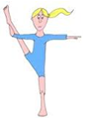
Art In art, the children will be developing their collage and sculpture skills. We will learn about the work of a range of artists, craft makers and designers, making links to their own work, in the context of learning about the sculptor Marc Quinn.
Music We are learning about pitch, rhythm and patterns.
PE Our PE sessions this term will be on Monday and Tuesday. In PE this half term we will be learning through Dance and Gymnastics. In our skills development we will be focusing on fundamental movement skills (body awareness, agility, balance and coordination) and then move onto Gymnastics (travelling, balancing, jumping, rolling) and creating our own ‘Gymnastic Stories’ (sequences and routines). We will continue to receive Football Skills by Will from DB Coaching.

RE We will cover ‘Questions that puzzle us’. The children will be encouraged to carry out discussions with their peers through thought provoking activities.
PSHEe To start us off in the new year our theme is ‘Going for Goals’. We reflect on our achievements and strengths, celebrate the achievements and strengths of others and set targets (resolutions) to ‘reach for the stars’. We will also be following the school-wide scheme Jed and Ted to learn about Drugs and Medicines later this half term.
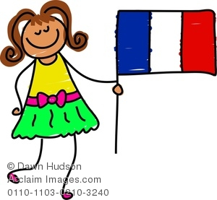
French We will continue to learn French through a mixture of: repetition, speaking and listening, songs and games.

HOMEWORK Homework will continue to be given out every Friday.
Thank you for your continued support, it is greatly appreciated.
Miss Caroline Pratt

